Gate Voltage Relation:
$$V_{G}=V_{FB}+ψ_{s}-\frac{Q_{s}\left(ψ_{s}\right)}{C_{ox}^{'}}$$
Flat-Band Voltage including oxide charges
$$V_{FB}=ϕ_{MS}-\frac{\left(Q_{f}+Q_{ot}+Q_{m}\right)}{C_{ox}^{'}}$$
This includes mobile ions, interface charge, trapped oxide charge,
If we represent in simple terms, as Qox or Qlums

$$V_{FB}=ϕ_{MS}-\frac{Q_{ox}}{C_{ox}^{'}}$$
Oxide Capacitance
$$C_{ox}^{'}=\frac{ε_{ox}}{t_{ox}}$$
$$C_{ox}=C_{ox}'A$$
Semiconductor Surface Charge
$$Q_{s}\left(ψ_{s}\right)=-sgn\left(ψ_{s}\right)\sqrt{2qε_{Si}N_{A}V_{T}F\left(ψ_{s}\right)}$$
Poisson-Boltzmann Function
$$F\left(ψ_{s}\right)=e^{-ψ_{s}/V_{T}}+\frac{ψ_{s}}{V_{T}}-1+{\left(n_{i}/N_{A}\right)}^{2}\left(e^{ψ_{s}/V_{T}}-ψ_{s}/V_{T}-1\right)$$
If we Define
$$η=\frac{ψ_{s}}{V_{T}}$$
Then
$$F(η)=e^{-η}+η-1+{\left(\frac{n_{i}}{N_{A}}\right)}^{2}(e^{η}-η-1)$$
Surface Potential Equation
$$f\left(ψ_{s}\right)=V_{FB}+ψ_{s}-\frac{Q_{s}\left(ψ_{s}\right)}{C_{ox}^{'}}-V_{G}=0$$
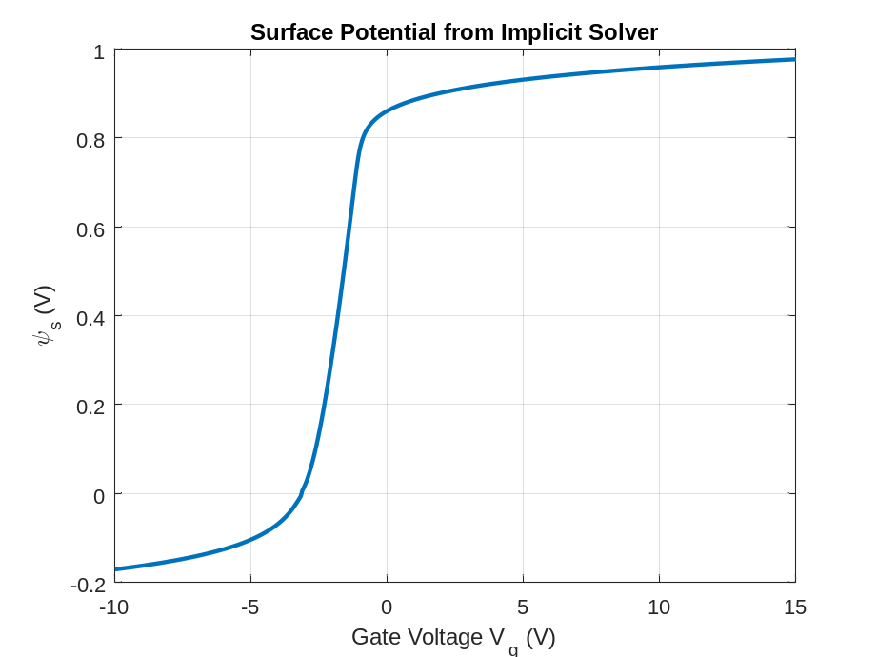
Newton Iteration
$$ψ_{s}^{k+1}=ψ_{s}^{k}-\frac{f\left(ψ_{s}^{k}\right)}{\left(df/dψ_{s}\right)}$$
Newton Derivative
$$\frac{df}{dψ_{s}}=1-\frac{\left(1/C_{ox}'\right)dQ_{s}}{dψ_{s}}$$
Semiconductor Capacitance
$$C_{s}=\frac{dQ_{s}}{dψ_{s}}$$
Charge Derivative
$$\frac{dQ_{s}}{dψ_{s}}=-\frac{\sqrt{2qε_{Si}N_{A}V_{T}}}{\left(2\sqrt{F}\right)} \frac{dF}{dψ_{s}}$$
Derivative of F
$$\frac{dF}{dψ_{s}}=\left(1/V_{T}\right)\left[-e^{-ψ_{s}/V_{T}}+1+{\left(n_{i}/N_{A}\right)}^{2}\left(e^{ψ_{s}/V_{T}}-1\right)\right]$$
Intrinsic MOS Capacitance
$$C_{MOS}=\frac{C_{ox}C_{s}}{\left(C_{ox}+C_{s}\right)}$$
Interface Trap Capacitance
$$C_{it}\left(f\right)=\frac{qD_{it}A}{\left(1+{\left(ωτ_{it}\right)}^{2}\right)}$$
Border Trap Capacitance
$$C_{bt}\left(f\right)=\frac{C_{bt0}}{\left(1+{\left(ωτ_{bt}\right)}^{2}\right)}$$
Poly Depletion Width
$$W_{poly}=\sqrt{2ε_{Si}ψ_{poly}/\left(qN_{poly}\right)}$$
Poly Capacitance
$$C_{poly}=\frac{ε_{Si}A}{W_{poly}}$$
Effective Oxide Capacitance
$$\frac{1}{C_{ox,eff}}=\frac{1}{C_{ox}}+\frac{1}{C_{poly}}$$
Gaussian Doping Profile
$$N_{A}\left(x\right)=N_{peak}\exp\left(-{\left(x-R_{p}\right)}^{2}/\left(2σ^{2}\right))\right)$$
Depletion Charge
$$Q_{d}=q\int_{0}^{W_{d}}{N_{A}}\left(x\right) dx$$
Series RC Impedance
$$Z=R_{s}+\frac{1}{\left(jωC_{total}\right)}$$
Total Equivalent Capacitance
$$C_{total}=\frac{\left(C_{ox,eff}\left(C_{s}+C_{it}+C_{bt}\right)\right)}{\left(C_{ox,eff}+C_{s}+C_{it}+C_{bt}\right)}+C_{par}$$
Measured Capacitance (Series Resistance Approximation)
$$C_{meas}=\frac{C_{total}}{\left(1+{\left(ωR_{s}C_{total}\right)}^{2}\right)}$$
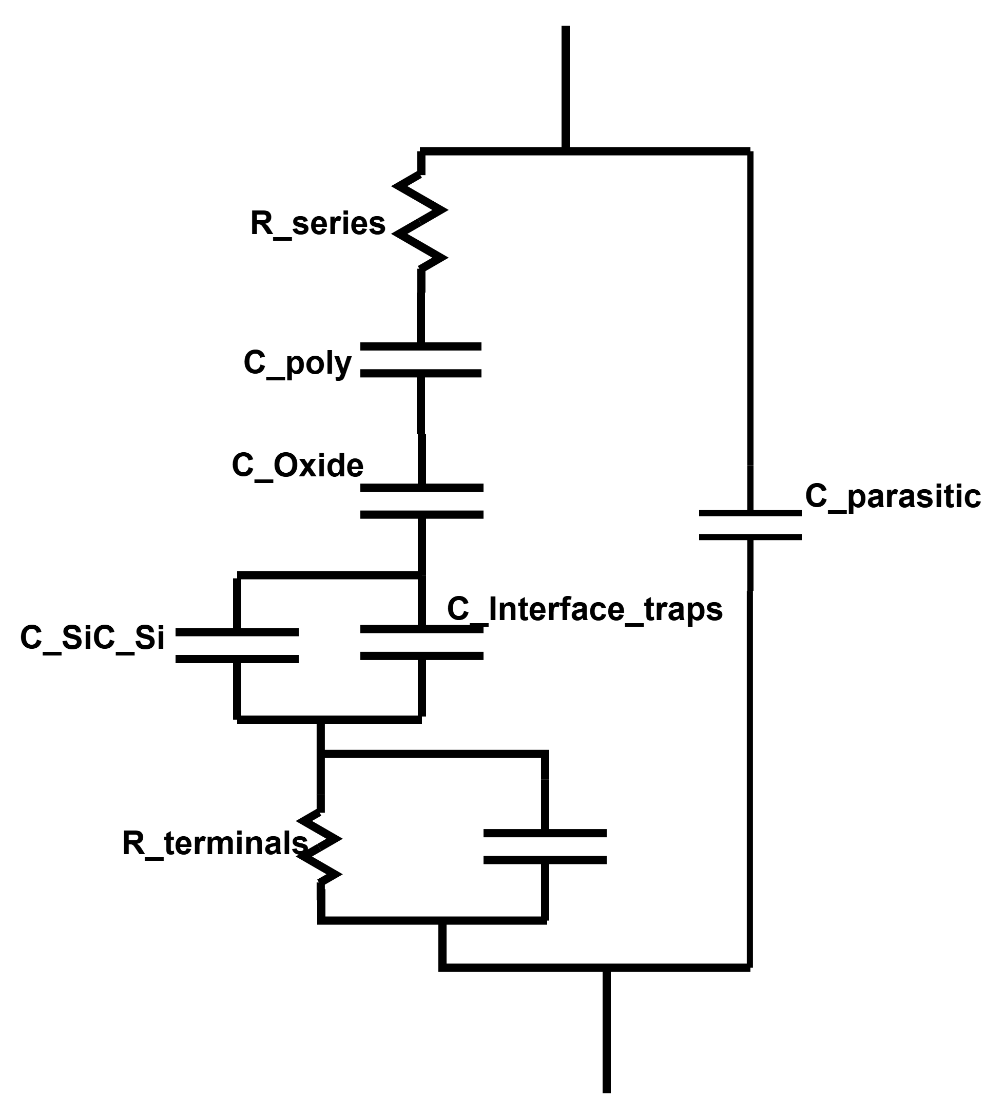

$$C_{it}\left(f\right)=\frac{qD_{it}A}{1+(ωτ_{it})^{2}}$$
$$C_{bt}\left(f\right)=\frac{C_{bt0}}{1+(ωτ_{bt})^{2}}$$
$$\frac{1}{C_{ox,eff}}=\frac{1}{C_{ox}}+\frac{1}{C_{poly}}$$
$$C_{total}=\frac{C_{ox,eff}\left(C_{s} + C_{it} + C_{bt}\right)}{C_{ox,eff}+C_{s}+C_{it}+C_{bt}}+C_{par}$$

